Shutdown Mainframe Procedure
Originator: | Sender De La Roca |  | Effective Date: | September 26, 2024
Manager Approval: | Sender De La Roca |  | Original Date: | September 26, 2024
 |  |  | Revision Date: | September 26, 2024
PURPOSE
The purpose of this procedure is to ensure a controlled and orderly shutdown of the IBM Mainframe system, minimizing the risk of data loss and ensuring all subsystems are properly stopped.

PROCEDURES
Procedures
- Notify Users
- Send a message to all TSO/E users to log off: SEND 'The system is being shut down in five minutes. Please log off.',NOW.
- Prevent New Logons
- Prevent new TSO/E logons: F TSO,LOGONS=NO.
- Verify Data Backup
- Ensure that all critical data has been backed up and verify the integrity of the backup files.
- Quiesce Workloads
- Quiesce batch and TSO workloads to avoid unexpected signals or abends.

- Shutdown STEPS:
- To shutdown any LPAR, type the command below from ANY MVS console:
Three LPAR names: PROD or TEST or TECH
    - to shutdown TECH LPAR: ro tech,s shutdown,ipl=tech
    - to shutdown TEST LPAR: ro test,s shutdown,ipl=test
    - to shutdown PROD LPAR: ro prod,s shutdown,ipl=prod
- Verify that the LPAR name matches the name to be shutdown.
Example LPAR names: PROD, TEST, TECH.
- After about 2 minutes, check active tasks by issuing the command: D A,L.
- Only these 14 tasks should remain active before they are all properly stopped by the shutdown script.
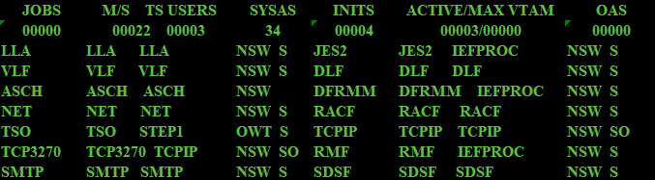
- In the example below, two tasks did not shutdown: MOBIUSH and TMONDB28
  - 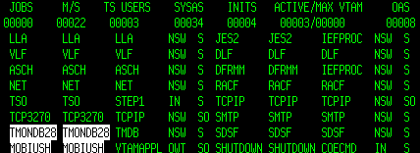
- manually issue stop command:
  - P MOBIUSH
  - P TMONDB28

- if MOBIUSH and TMONDB28 still do not stop, issue cancel command:
  - C MOBIUSH
  - C TMONDB28
- Repeat steps 6 and 7 for all other task not down besides those in step 4
- Once all other tasks besides those in step 4 are down, the shutdown procedure will continue and stop all those tasks in step 4 gracefully.
- After all tasks are down, the messages below will show, (TECH LPAR as example) TECH LPAR is ready to IPL. ( V XCF,TECH,OFF)

  - 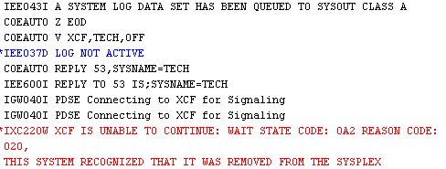
- *AFTER* you see the above RED messages, this means that the LPAR name shown has been completely STOPPED.
  - IXC220W XCF Unable to Continue Wait: 0A2 Reas: 020
This system recognized that it was removed from the SYSPLEX.IPL
- Now the LPAR is down and you can proceed to IPL the system only after you see the above RED messages.
- DO NOT IPL until the RED messages have been issued.

